Augustus Mendy

Southern New Hampshire University

CS-340-10011-M01

Professor Gebre-Amlark

March 9, 2025

## 3-1 Milestone: Database Indexing and Authentication

1. In Apporto, open the terminal window to access the Linux shell. Upload the Austin Animal Center (AAC) Outcomes data set into MongoDB by **importing a CSV file using the appropriate MongoDB import tool**. Use the database name “AAC” and collection name “animals.” Complete the import using the mongoimport tool, and **take screenshots** of both the import command and its execution.

1. After importing your data set, open the mongo shell. **Create a simple index** on the key “breed.” Show an example query using this index, and use the **explain function** to verify that the index will be used. **Take screenshots** of your example query.

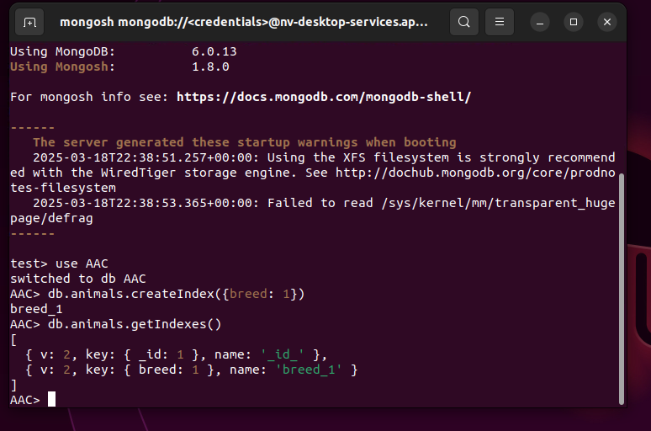

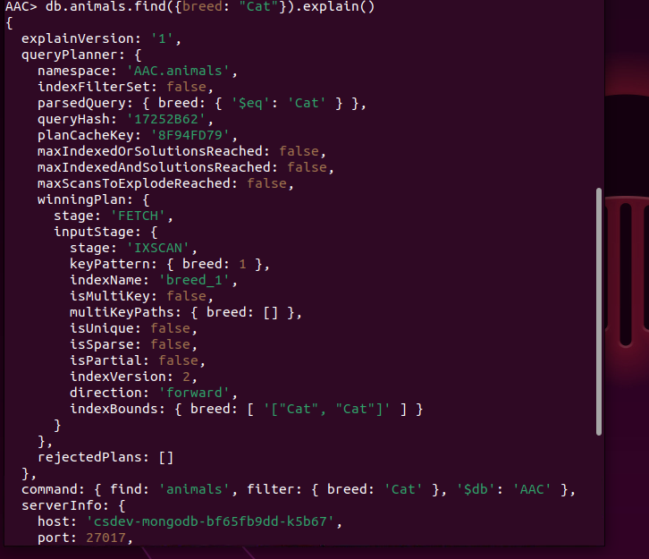

1. **Create a compound index** that will improve the performance of queries looking for breeds that have an “outcome_type” of “Transfer.” Show an example query using this compound index, and use the **explain function** to confirm the index will be used. **Take screenshots** of your example query.

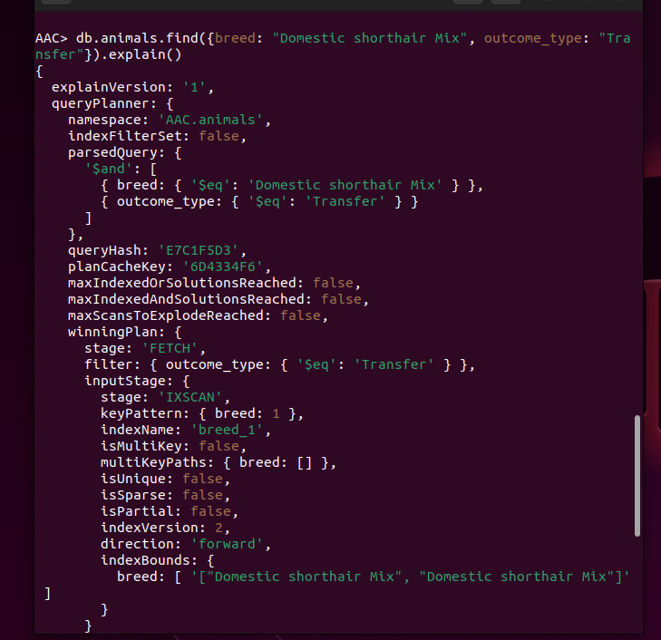

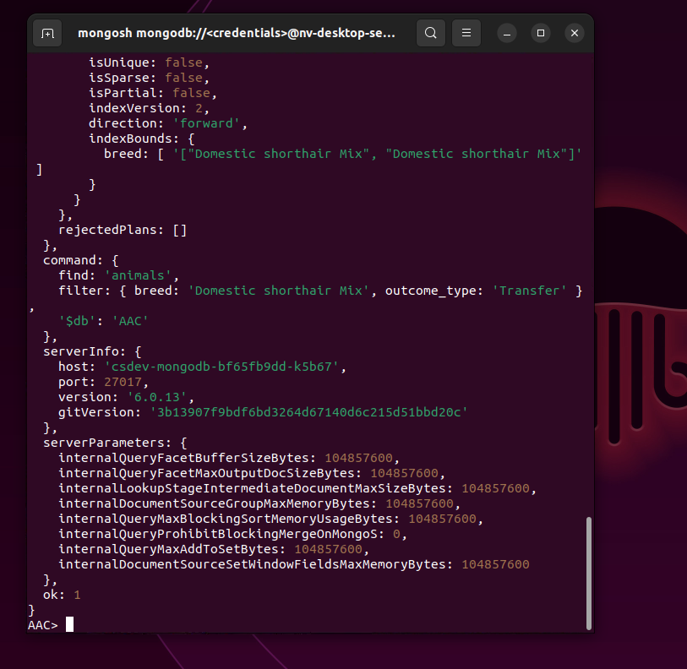

**Part II: User Authentication**

1. **Create a new user account called “aacuser”** for the database AAC in the mongo shell. Refer to steps 6–7 of the MongoDB [Manual Enable Access Control](https://www.mongodb.com/docs/v6.0/tutorial/enable-authentication/) tutorial for help with this task. You will need to modify the commands so the account name is “aacuser.” Additional information with respect to user management may be found in the [User Management in MongoDB](https://learn.snhu.edu/content/enforced/1860280-CS-340-10011.202516-1/course_documents/CS%20340%20User%20Management%20in%20MongoDB.pdf?isCourseFile=true&ou=1860280) document.

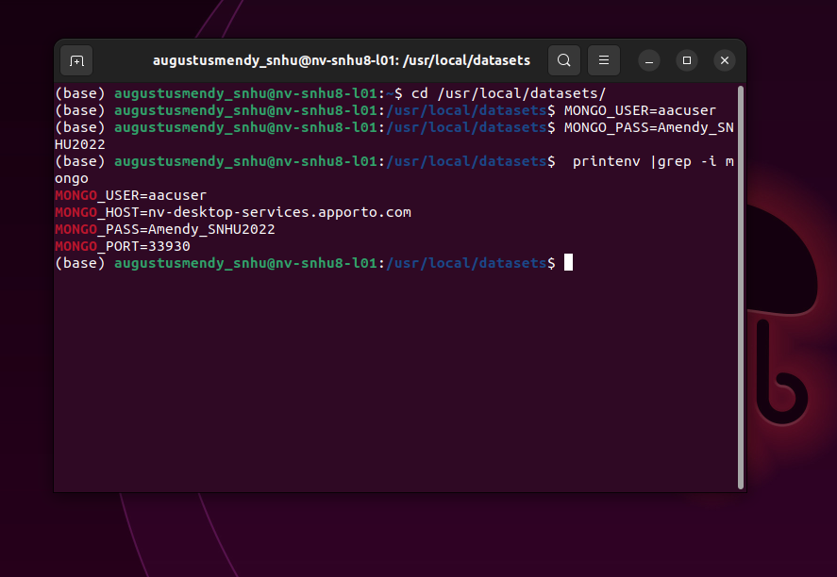

1. Take a screenshot of your login process to MongoDB using the mongo shell. Be sure you can access MongoDB and list the databases using both the admin and aacuser accounts. This task will verify that your accounts are working. You should be able to include the login commands for both accounts in one screenshot, but if you cannot, include two screenshots to show both login commands.

